23CSE202 DATABASE MANAGEMENT SYSTEMS
S3 B.Tech CSE
Department of Computer Science and Engineering
Amrita School of Computing, Amritapuri Campus

3. Database Design Document

Group No :
Team Members :
Roll No | Student Name
AM.SC.U4CSE25207 | Ayush Kushwaha
AM.SC.U4CSE25237 | Nayanteerth Akhil
AM.SC.U4CSE25246 | Sanjana S
AM.SC.U4CSE25254 | Tejas Shrivastava
AM.SC.U4CSE25256 | Varun Nagnath Lokare

Project Title : StockTrace

3.1. Detailed description of the project
StockTrace is an inventory management system which uses RFID tags to keep track of electronic and robotics components. The system has a web interface through which users can view products, suppliers, orders and stock details. RFID tags are read using an Arduino and the stock information is stored in a SQLite database.
Each product has a unique RFID tag ID. When a tag is scanned, a stock movement is created with the action IN or OUT, quantity and reason. The stock quantity of the product is then updated. The system also keeps track of suppliers and purchase orders. Users have different roles such as admin, manager and staff.
The main entities in the system are Product, Supplier, Order, Stock Movement, User, Audit Log and Setting. The important rules are:
• Each product has a unique RFID tag ID.
• Each stock movment belongs to one product.
• Each order belongs to one supplier.
• Stock movement can be either IN or OUT.
• User email IDs are unique and users can have the roles admin, manager or staff.
• Products can be markd for reorder when their quantity goes below the reorder point.

3.2. ER Diagram
The ER diagram shows the entities used in the application database along with their attributes, primary keys and relationships.
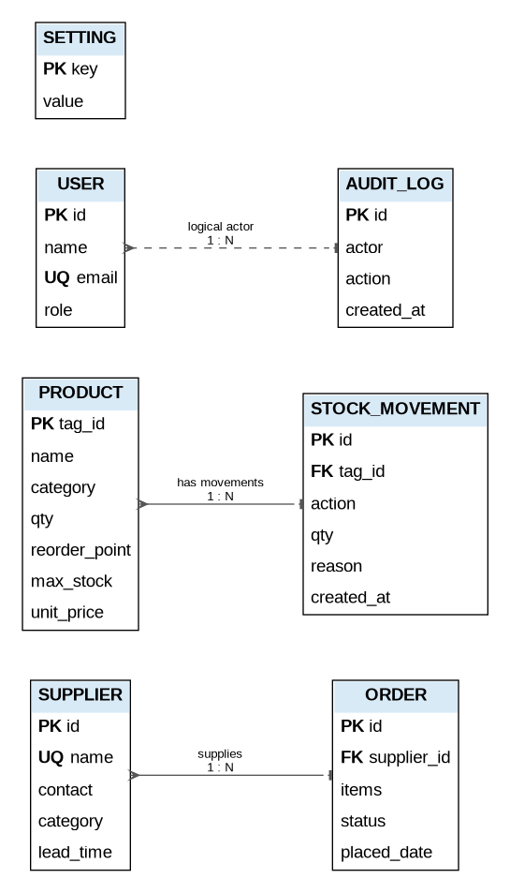
Figure 1: ER diagram of StockTrace

3.3 Relational Schema
The relational schema is derived from the ER diagram is given below.
Relation | Schema
SUPPLIER | SUPPLIER(id, name, contact, category, lead_time) PK: id UQ: name
PRODUCT | PRODUCT(tag_id, name, category, qty, reorder_point, max_stock, unit_price) PK: tag_id
ORDER | ORDER(id, supplier_id, items, status, placed_date) PK: id FK: supplier_id
STOCK_MOVEMENT | STOCK_MOVEMENT(id, tag_id, action, qty, reason, created_at) PK: id FK: tag_id
USER | USER(id, name, email, role) PK: id UQ: email
AUDIT_LOG | AUDIT_LOG(id, actor, action, created_at) PK: id
SETTING | SETTING(key, valu) PK: key
Relationships:
• SUPPLIER (1) — (N) ORDER
• PRODUCT (1) — (N) STOCK_MOVEMENT
• USER (1) — (N) AUDIT_LOG is a logical relationship; actor is stored as text in the current database.
• SETTING is independent of the other relations.

3.4 Normalization and Functional dependency analysis

Functional Dependencies
The main functional dependencies are:
• SUPPLIER: id name, contact, category, lead_time
• SUPPLIER: name id, contact, category, lead_time
• PRODUCT: tag_id name, category, qty, reorder_point, max_stock, unit_price
• ORDER: id suplier_id, items, status, placed_date
• STOCK_MOVEMENT: id tag_id, action, qty, reason, created_at
• USER: id name, email, role
• USER: email id, name, role
• AUDIT_LOG: id actor, action, created_at
• SETTING: key value

Candidate Keys and Attribute Closure
Candidate keys can be found using attribute closure. Some important closures are:
• SUPPLIER: id+ = {id, name, contact, category, lead_time }. Hence id is a candidate key.
• SUPPLIER: name+ = {name, id, contact, category , lead_time}. Since name is unique, name is also a candidate key.
• PRODUCT: tag_id+ = {tag_id, name, category, qty, reorder_point, max_stock, unit_price}. Hence tag_id is the candidate key.
• ORDER: id+ = {id, supplier_id, items, status, placed_date}. Hence id is the candidate key.
• USER: id+ = {id, name, email, role}. Hence id is a candidate key.
• USER: email+ = {email, id, name, role}. Since email is unique, email is also a candidate key.
• STOCK_MOVEMENT, AUDIT_LOG and SETING have id, id and key respectively as their candidate keys.

1NF: All the Normalization
relations have atomic attributes and each row can be uniquely identified using a key. Therefore the relations satisfy 1NF.
2NF: All the candidate keys in the implemented relations are single attributes. Hence there are no partial dependencies and the relations satisfy 2NF.
3NF: The non-key attributes depend on the keys and there are no transitive dependencies between non-key attributes. Therefore the relations satisfy 3NF.
BCNF: For every non-trivial functional dependency, the determinant is a candidate key or a superkey. Hence the implemented relations satisfy BCNF. The only non-trivial FD is id → {tag_id, action, qty, reason, created_at}, and id is the candidate key, so the determinant is a superkey. BCNF holds.

